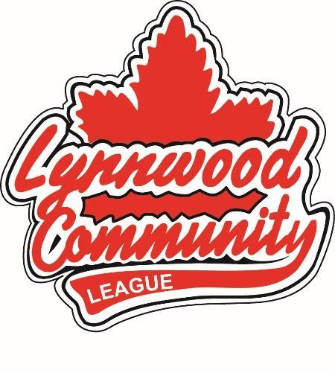
AGM Bylaw Proposal

SUBMITTED BY:
PHONE:
EMAIL:

PROPOSAL:

REASON:

PREVIOUS BYLAW OR POLICY (IF APPLICABLE):

EMAIL TO: secretary@lynnwoodcommunity.com

